POLICIES AND PROCEDURES

OSL.SOP.XVII.009
#27 Packing and shipping procedures of Ebola vaccines(V920) to vaccination sites
WRE/SHO
OSL Standard Operating Procedure
Target Audience: Technical Logistic & EPI officers

DISCLAIMER

Standard Operating Procedures (SOPs) provide a step-by-step guide for staff directly involved in the processing of administrative actions to support and facilitate the implementation of WHO policies and procedures. The SOPs are for guidance only; they are neither authoritative nor binding. The SOPs reflect the policies and procedures of WHO at the time of writing; however, policies and procedures change from time-to-time. In the case of a conflict between the SOPs and the WHO e-Manual provisions, the WHO e-Manual provisions take precedence.

DOCUMENT SPECIFICATIONS

Version | Date of revision | Author (s) / Dept / Unit | Approver | Indicate which section (s) changed compared to previous version
1.0 | 18/08/2018 | Jordi Sacristan / SHO/OSL | AIT-IKHLEF, Kamal; COSTA, Alejandro;  MOLINARO, Paul; | Reviewed and approved on 30/08/2019

INTRODUCTION

  - Purpose
To describe the detailed process on how Ebola Zaire vaccine (V920) should be packed into the Passive Vaccine Carrier Device (PVCD) to minimize the risk of damage during transportation within the country, from central stores (from the active ultra-cold chain facilities) to the field identified vaccination points.

  - Scope
The information described in this SOP is for study staff involved in the vaccination and ring definition around an index case of Ebola Virus Disease (EVD).

  - Principles
The current Ebola Zaire vaccine (V920) must be stored and transported in very low temperature at ≤-60 °C. There is a risk of loss of efficacy if the vaccine is expose to a higher temperature than -60 °C during transport between vaccine stores.
Responsible personnel should ensure that the packing process is correctly organized in an appropriate dedicated working area, to minimize manipulation time, thus reducing temperature loses and vaccines exposure.

MATERIALS

2.1. Ultra-Low Temperature Freezer (ULTF).

2.2. Low Temperature Freezer (LTF).

2.3. Passive Vaccine Carrier Devise (PVCD) (ARKTEK mod. Ref. YBC -5 E) ≤ -60 °C

2.4. Passive Vaccine Carrier Devise (Any Vaccine Carrier PQS) +2 °C to +8 °C

2.5. PCM accumulators (Phase Changing Material).

2.6. Ice Packs

2.7. Dry ice.

2.8. Temperature monitoring device.

2.9. Tools set (cutting pliers, screw drivers, knife, etc.)

PROCEDURES
  - Requirements:
    - All staff involved on the packaging and vaccine transport to the field have been properly trained on the principles and procedures of using the Ultra Cold Chain equipment (UCC).

    - All involved staff is provided with a clear and detailed term of reference, with clear understanding and agreement of task(s) to be performed, and with clear information flow and reporting procedures.

    - All documents (temperature control cards, daily checking lists, etc.). Should be adapted to the context and approved.

  - Pre-shipping of the Passive Ultra Cold Chain (Preparation of PCM accumulators and Ice Packs):

    - Based on number of vaccines and locations, prepare the shipping materials for the passive UCC accordingly (number of ARKTEK, vaccine carriers, etc.).
    - Ultra-frozen PCM accumulators need to be replaced every 5 days to maintain the Passive UCC capacity (≤ -60 °C).
    - Start-up process (first time ultra-freezing process): freezing the PCM accumulators. Place the required number of PCM accumulators (8 per ARKTEK) in the freezer room or the Low Temperature Freezer (active negative cold chain), set at temperature -20 °C; and leave them until they are fully frozen (approx. 24h).
    - Ultra-freezing process for the PCM accumulators: Move the pre-frozen PCM accumulators from the -20 °C freezer (or from the returned ARKTEK if they are already below -25 °C) into the ultra-low temperature freezer set at -80 °C. Wear cryo-gloves. To avoid activation of the temperature alarm of the ULTF (Ultra-low temperature freezer), due to temperature variation, follow next steps:

        - When transferring the PCM accumulators (maximum 8 units per load), set up the alarm range of the ULTF at -65 °C.
        - Allow time for temperature inside of the ULTF to stabilized and then reach -80 °C. The whole process may require between 18-24h.
        - PCM accumulators must be kept for minimum 48h at -80 °C before loaded again into the ARKTEK
3.2.5 Once all transport arrangements have been done and are ready (dates, locations, quantities, etc.), transfer the PCM accumulators into the PVCD — 8 units for each device — and allow temperature to descend and stabilize before loading vaccines.

  - Packing and shipping vaccines in the PVCD (ARKTEK) for transport to the field:

    - Ebola Zaire vaccine (V920) must always be transported to the field using PCM accumulators (the ones used in the PVCD); or dry ice as alternative if they are not available.
    - Wash hands thoroughly before handling vaccine boxes and vaccines vials.
    - Insert batteries and switch on the temperature control device of PVCD (you may need to connect it to the computer with the corresponding software).
    - Wear your cryo-gloves.
    - Pre-cool the PVCD, introducing the PCM accumulators and the racks, and allow temperature to descend and stabilize, prior to packing the vaccines inside. Keep them always clean, in an airconditioned or well-ventilated room if possible.
    - Use the correct size and number of packs for the chosen container. Line the container exactly as described on the instructions from the manufacturer.
    - Pack the vaccines’ vial racks in the PVCD (vials need to be in horizontal position to stack the containers).
    - Close the lid and engage the latch.
    - Place the packing list and the temperature monitoring report sheet in the pocket/pouch on top of the PVCD container.
    - Label the container indicating destination, contact person and contact telephone number. Verify consignee details with recipient.
    - Keep the container in the packing room, or in a covered holding area, until all other containers in the consignment have been packed.
    - Load the consignment in the assigned transportation vehicle (if possible this should be adapted as much as possible; for example: refrigerated or AC cooled vehicle). Containers must be kept away from direct sunlight and heat sources during transportation.
  - Maintaining the Passive Ultra cold chain capacity at the field level:
    - Monitor the PVCD temperature and keep tracking records (twice a day: morning and afternoon). In case of temperature deviation or device malfunctioning refer to SOP30_WRE-SHO-OSL.
    - To maintain passive ultra-cold chain at the field, PCM packs must be replaced within 5 days period, including transport.
    - At the ACC level (Active Cold Chain): Place the ultra-frozen PCM accumulators (-80 °C) inside the ARKTEK (PVCD) and after insert the empty racks (to avoid internal movements during transport), close the lid and the latch, activate the temperature monitoring device, record the date, time and temperatures and when the ARKTEK has reach the temperature of ≤ -60 °C. If new vaccines need to be sent, control the temperature of the ARKTEK and cross-check date and time when the PCM have been loaded. If sufficient lead time at ≤ -60 °C is guaranteed, then insert vaccines inside the racks and complete the recording form with quantities and batch numbers.
    - Label the boxes with following details; Origin, destination, date, time, temperature, quantity, batch numbers, expiring date and inform consignee of shipment and request vaccines arrival report (VAR).
    - At the field level: At the field level: When a ready-to-use ARKTEK without vaccines is received, remove the empty racks, and replace with the original ones containing the vaccines (this must be done within the shortest time, to minimize vaccines exposure to the heat). Put the empty racks received into the already used ARKTEK (temp > -60 °C) and return them to the central store for reconditioning.
    - At ACC level: When already used ARKTEKs are received, remove PCM accumulators, and return them directly to the active ULTF (-80 °C).
  - Packing and shipping vaccines within the passive ultra-cold chain devices for transport and use to the vaccination points:
    - Prior to vial puncture, vaccines should be kept at standard cold chain temperature in standard passive or active cold chain equipment at +2 °C to +8 °C for maximum 14 days. Following vaccine vial puncture, vaccines should be kept at +2 °C to +8 °C range temperature no more than 5 hours.
Note: Once vaccines are defrosted, they cannot be frozen again. Quantities should be correctly adjusted to the daily vaccination plans to reduce waste.
    - Produce the required number of Icepacks and freeze them using the active LTF (low temperature freezer, from 0 °C to -20 °C). Ensure enough quantity of Ice pack units, and sufficient local freezing capacity as well.
    - Between 1 and 2 hours before vaccination remove requested number of vials from the ARKTEK and place them into an empty vaccine carrier (protected from direct sunlight). Watch the vial/s until is/are defrosted, then add the ice packs into vaccine carrier and a temperature monitor.
    - Record the temperature in the monitoring card, including date and time every hour and replace Icepacks accordingly if necessary.
    - Keep vaccine carrier protected from direct sunlight, in a cooler place, under the shadow, in a well-ventilated place. Minimize openings as much as possible.

REPORTING

  - The transportation of EVD vaccines within a country, from the active ultra-cold chain facilities (ACC) to the field (vaccination points), using the passive ultra-cold chain capacity, requires continued and integrated temperature monitoring system.
  - Vaccine temperature must be all the time monitored and recorded to ensure their validity and efficacy.
  - Any physical movement of vaccines inside UCC and/or CC devices (active and passive) needs to be recorded.
  - Vaccines temperature during storage and transport need to be reported through a clear and well-stablished communications channels. (see SOP#30_WRE-SHO-OSL).
  - Any failure, or any problem encountered must be reported immediately to the designated UCC manager as instructed in SOP#30_WRE-SHOO-OSL. (see flow chart in annex).
  - At Coordination level:

    - Only designated responsible can initiate formal written requests, including quantities and destination, instructing the designated central stores to release new vaccines to the field in accordance with needs and vaccination plans.

  - At ACC Level:

    - Temperatures in different ultra-low temperature freezer (for vaccines and PCM packs) will be recorded twice a day (morning and evening) and recorded in the “Temperature Monitoring Form” (see annex below and SOP#30_WRE-SHO-OSL) placed physically on the door of each Ultra-Low Temperature Freezers (ULTF).
    - Once per week, a scanned copy/image of both forms will be sent by email, including temperature data report downloaded from the ULTF, to the designated UCC manager. (see SOP#30_WRE-SHO-OSL).
    - When sending ARKTEK to the field with vaccines from the active cold storage premises fill both “Vaccines Stock follow up Form” and “Temperature Monitoring Form” and attach them to the shipping documents (see annex).
    - When sending ARKTEK to the field without vaccines fill the “Temperature Monitoring Form” and attach them to the shipping documents (see annex).
  - At Field Level:

    - ARKTEK’s temperatures will be recorded twice a day (morning and evening) and recorded in the “Temperature Monitoring Form” (see annex).
    - When EVD vaccines are transferred from the ARKTEK to the vaccine carrier for use, the movement should be recorded including the date, time, number of doses, batch number and destination.
    - If there is a need of extra EVD vaccine doses, a written request will be submitted through the Coordination level for approval.
    - When new vaccines are received, inform Coordination Level of it and include information on date, time, temperature of the PVCD and number of doses and batch numbers.
    - Vaccine carrier temperature (+2 °C + 8 °C) should be electronically monitored and recorded physically every hour in the dedicated form. Information will be kept for final analysis.

REFERENCE MATERIALS

  - . Related SOP’s

- SOP#28_WRE-SHO-OSL- EVD vaccine Reception in the Country.
- SOP#30_WRE-SHO-OSL- UCC Temperature Monitoring and incident reporting.
- SOP#31_WRE-SHO-OSL- Setup of Ultra-Cold Chain for EVD vaccination.
- SOP#32_WRE-SHO-OSL- Ultra-Cold Chain Decommissioning.

PROCESS FLOW
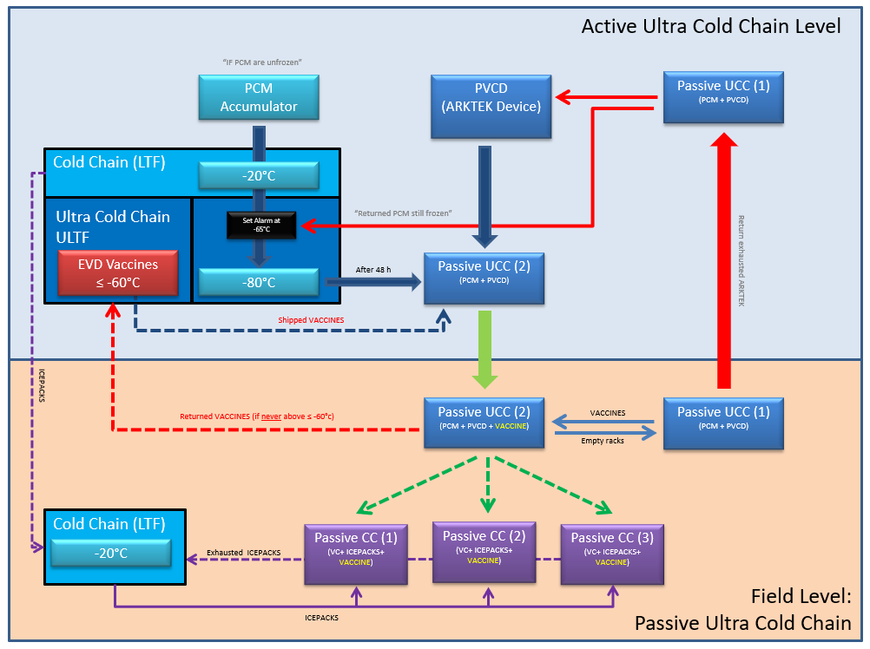

APPENDIX

- Glossary

ACC: | Active Cold Chain. Infrastructure depending on the power supply, with capacity unlimited cold production meanwhile there is an active power source.
CC: | Cold Chain System. Includes both active and passive devices (temperature ranges from -25 ° to 8 °C)
EVD: | Ebola Virus Diseases.
HQ | Headquarters. It refers to World Health Organization in Geneva.
LTF: | Low Temperature Freezer. Active negative cold chain device. Provides temperatures from 0 °C to -25 °C.
OSL: | Operations Support and Logistics unit, in the Emergency Operations Department in WHO
PCC: | Passive Cold Chain. Infrastructure not depending on the power supply, but on passive devices with high capacity of heat absorption. Its capacity is time limited.
PCM: | Phase Changing Material. Refers to the liquid used in the accumulators of the PVCD or ARKTEC© devices.
PTAEO: | Budget Line defined inside the organization (WHO).
PVCD: | Passive Vaccine Carrier Device. Refers to the ARKTEC© devices.
TOR: | Terms of Reference. Detailed list of objectives and tasks for an identified working position.
UCC: | Ultra-Cold Chain. Include both active and passive devices (temperature ranges from -50 °C to -85 °C)
ULTF: | Ultra-Low Temperature Freezer. Active ultra-cold chain device. Provides temperatures from -50 °C to -85 °C.
UPS: | Uninterruptible power supply. Electrical device.
VC: | Vaccine carrier. Passive cold chain device. Provides temperatures from 2 °C to 8 °C, using ice packs.
WHO: | World Health Organization
WHO CO: | Country Office of WHO.

